"Gendered Patterns of Lethal and Self-Harming Violence: An In-depth Analysis in Italy and the European Union"

Key Words: Gender-based violence, Homicide comparison, Suicide trends, Comparative analysis, Italy, European Union, ISTAT, EUROSTAT, R

1. Introduction

This project explores gender-specific patterns of lethal violence and self-harm in Italy, focusing on the relationships between victims and perpetrators. The study investigates murder cases involving women and men, examining the dynamics with relatives, partners, former partners, acquaintances, or unknown individuals. Comparative analyses between genders aim to uncover any notable differences and extend the investigation to other European Union countries. Additionally, the research delves into suicide rates and attempts, seeking to identify significant gender disparities. Utilizing ISTAT and EUROSTAT datasets, the study employs graphical representations created with R to visually highlight and compare these intricate societal phenomena.

2. Data Used

The data utilized is derived from the processing of datasets available in both CSV and XLSX formats. The primary data sources include ISTAT, the Italian National Institute of Statistics, and EUROSTAT, the statistical office of the European Union:

* [Giornata Mondiale per la prevenzione del suicidio: le statistiche dell’ISTAT](https://www.istat.it/it/archivio/203366);
* [Le vittime di omicidio: ANNO 2022, ISTAT](https://www.istat.it/it/archivio/291266#:~:text=Il%2092%2C7%25%20degli%20italiani,totale%20delle%20126%20donne%20uccise);
* [Intentional homicide victims by victim-offender relationship and sex - number and rate for the relevant sex group, EUROSTAT](https://eige.europa.eu/gender-statistics/dgs/indicator/genvio_int_adm_oth__crim_hom_vrel).

All the datasets can be downloaded from the “[chiesastefano/rProject](https://github.com/chiesastefano/rProject)” GitHub repository.

3. Ask Phase

Gender violence is a highly sensitive topic that has, in many instances, transformed into a political symbol for those who feel directly affected by it. Numerous individuals argue that women are inherently more susceptible to being victims of violence, often attributing the role of primary perpetrators to close male associates. The objective of this paper is to investigate whether this assertion is supported by empirical evidence, with a specific focus on cases in Italy and selected European Union countries. To achieve this, we will examine data on homicides and suicides, analysing the dynamics of the relationship between the perpetrator and the victim.

4. Methodology

4.1 Code

The data was processed using the R programming language within the R Studio environment, and version control was conducted through GitHub.

4.2 Libraries and Packages Used

During the coding process, the following libraries were utilized:

* Tidyverse: for data visualization;
* Readxl: to read XLSX files;
* Readr: to read CSV files;
* Ggplot2: for graphical visualization;
* Dplyr: to manipulate data;
* Countrycode: to translate country names from Italian to English.

4.3 Country translation

As mentioned earlier, ISTAT is the Italian Statistical Institute, and the majority of its data is in Italian. This language difference could pose challenges when interacting with certain parts of the code, such as the "geom_map" function in ggplot2. To address this, I created a mapping of every country in the Italian dataset, linking them to their English translations. Subsequently, I utilized this mapping to translate names as necessary within the functions.

4.4 Code Structure

To interpret the data, I used several data visualisation methods (graphs). The dataset contained different data according to year, gender and country. To keep the code in order and avoid duplication, I used parameterised functions that I called whenever I needed a different graph. The function names, consultable in the directory “R/graphs.R” are the following:

* relationship_graph(gender): it shows the relationship between the murdered and the victim (male or female);
* suicide_graph(): it compares the trend trough the years of Italian suicide data of females and males;
* murders_europe_gender(): it shows the total number of homicides per 100,000 inhabitants in Italy, highlighting the gender of the victim;
* murders_europe_murderer(gender, year): it show the total number of homicides per 100,000 inhabitants in some European countries, where the murderer is a relative, the partner or one of the two. The function gives the opportunity of selecting a gender (“M” or “F”) and a year;
* murders_time_series(): it compares the total murders per 100,000 inhabitants of Italy and of the Europen Union;
* murders_map(year): it creates a map of Europe, colouring the countries based on the number of murders per 100,000 inhabitants in a given year.

5. Results

The investigation commenced by examining the homicide trends in Italy, distinguishing between male and female victims, and scrutinizing the relationships between victims and perpetrators. Six distinct relationship categories were considered: partner (spouse, cohabitant, boyfriend/girlfriend), former partner (former spouse, former cohabitant, former boyfriend/girlfriend), other types of cohabitants, other types of relatives, unknown, and undefined. The primary objective of this approach is to compare the overall murder rates and explore potential cultural influences behind these homicides. Maintaining a consistent scale ensures a reliable basis for meaningful comparisons.

*Source: ISTAT*

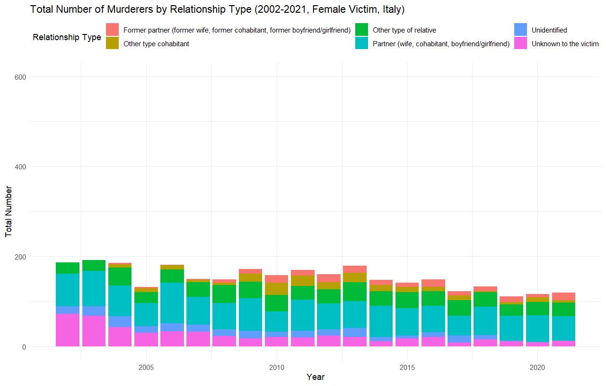

*Source: ISTAT*

The findings are clear: the total number of homicides with male victims surpasses those with female victims. Among male victims, the primary categories of perpetrators are classified as "unknown to the victim" and "undefined." Conversely, among female victims, the prevalent categories include "partner" and "other types of relative." Additionally, a discernible decrease is observed in male homicides, while female homicides exhibit a stable trend.

Examining beyond the Italian borders provides insight into whether this trend is specific to Italy or extends more broadly. The normalization of data by population size is imperative to identify the country with a higher prevalence of partner-related homicides.

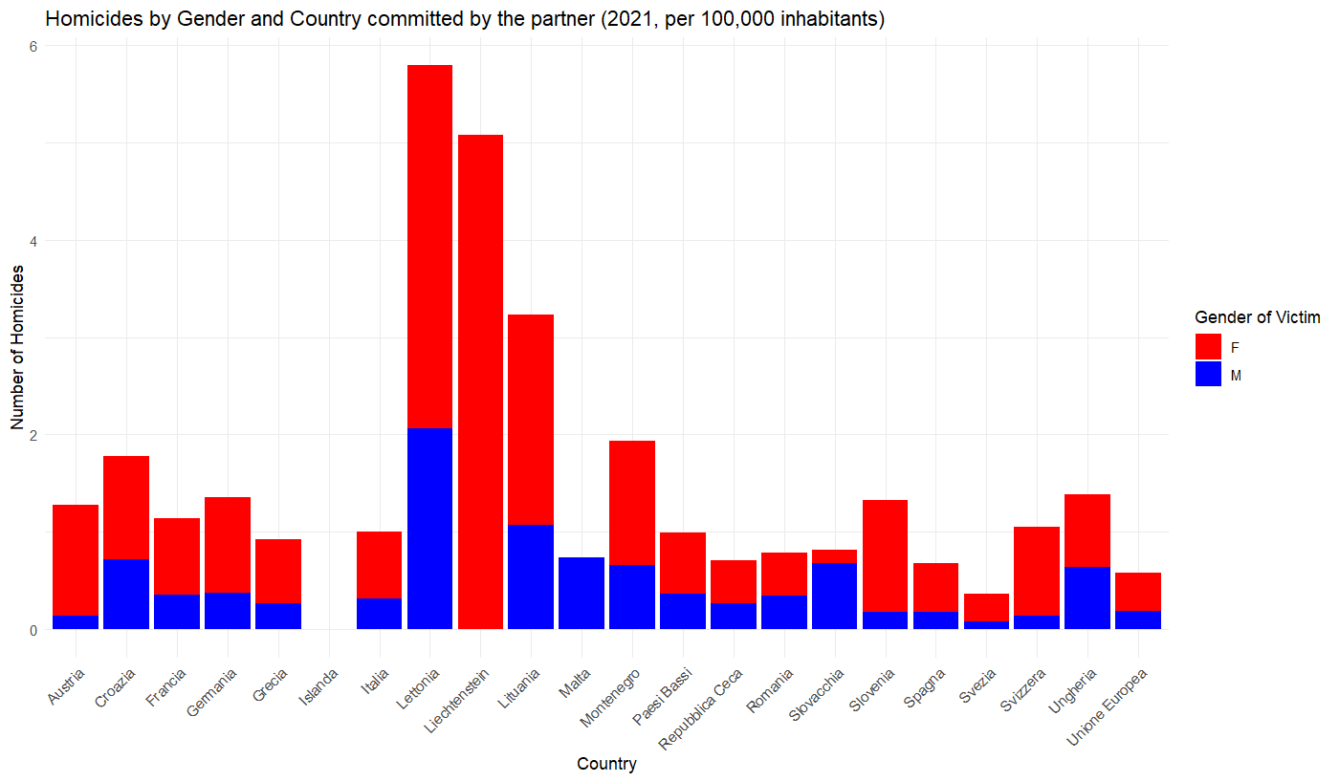

*Source: EUROSTAT*

Based on the data, the majority of countries exhibit a higher incidence of homicides with female victims, with exceptions noted in Malta and Slovakia. Italy does not rank as the worst country in Europe in this particular aspect. Countries such as Latvia and Liechtenstein surpass Italy's rates, with more than four times the occurrence.

The investigation can delve deeper by examining the number of homicides per 100,000 inhabitants for each country, categorized into family, partner, and a combined category of family or partner. The inclusion of the latter category addresses instances where uncertainty exists regarding whether the murderer is a relative or a partner. This ambiguity arises, for instance, when the spouse is considered both a relative and a partner in certain countries.

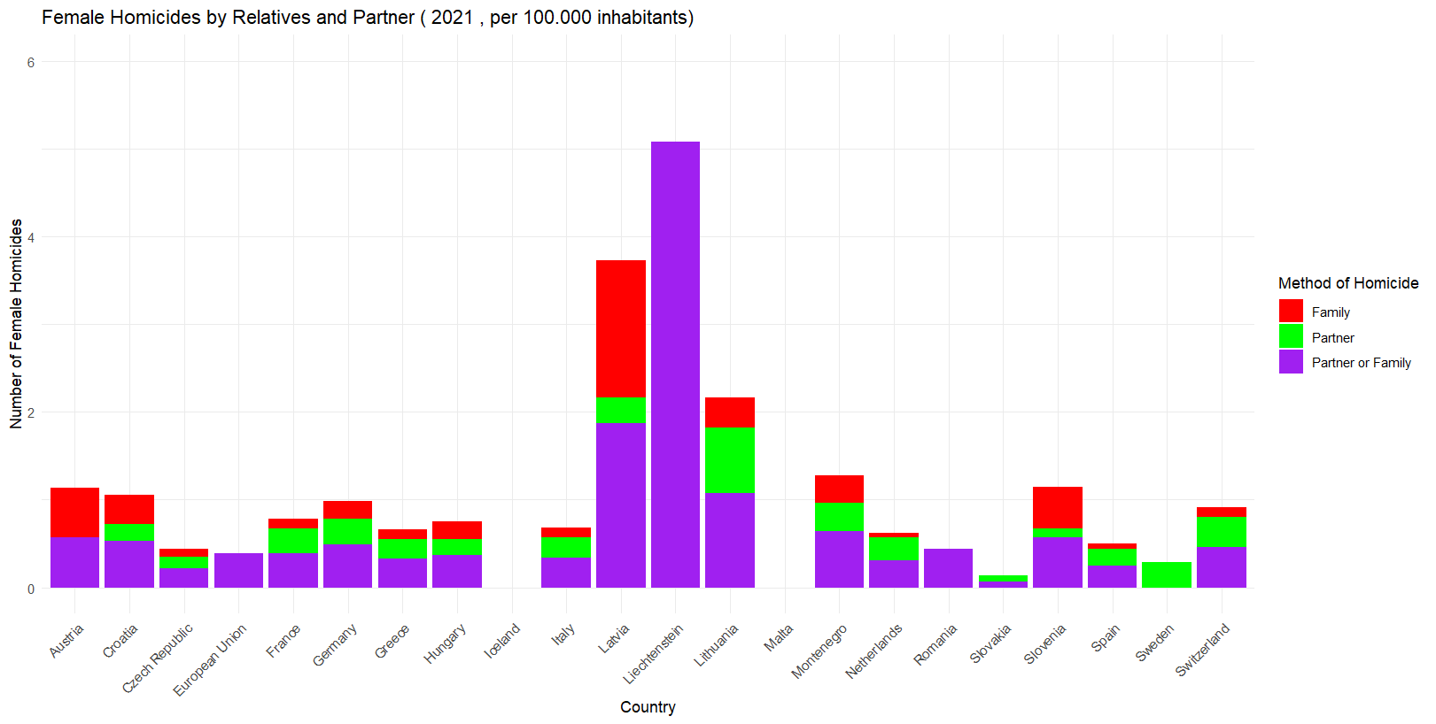

*Source: EUROSTAT*

*Source: EUROSTAT*

As mentioned earlier, the incidence of murders per 100,000 inhabitants is confirmed to higher for females than for males. However, there isn't a distinct and consistent overall dominance of one category over another in these European countries.

The dataset also includes the overall number for the European Union. Upon comparing the data series, post-normalization, a notable observation is that in Italy, the number of homicides related to partners and relatives is considerably higher than in the European Union as a whole.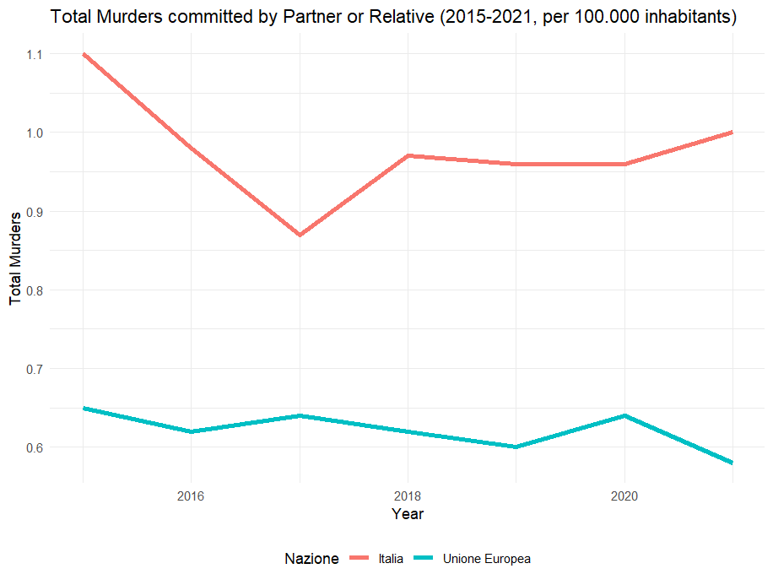

*Source: EUROSTAT*

While the number of murders appears stable, it's important to note that the time series is relatively short, making it challenging to draw definitive conclusions about the long-term trend.

To enhance the visualization of the issue, a map has been created using the data to depict the homicide rates across Europe. In this representation, both male and female homicides have been considered and counted.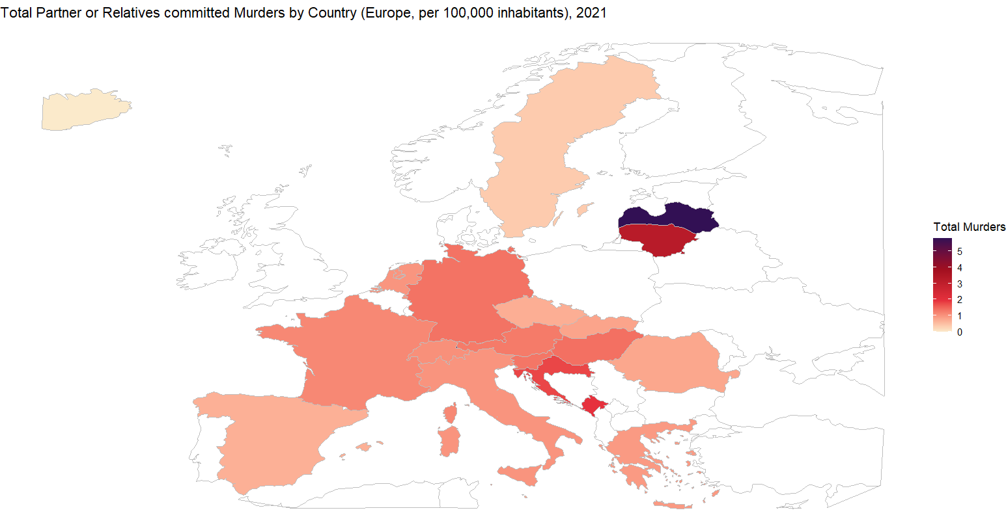

The map illustrates that countries with notably higher incidences of such homicides include Latvia, Lithuania, Croatia, and Montenegro. Italy, in comparison, does not appear to have as high rates compared to other European countries, contrary to its position in the previous time series where it exceeded the EU value. This discrepancy arises from the fact that the EU does not represent the entirety of Europe (the continent), and the dataset lacks specific data for every EU country while encompassing data for the EU as a whole.

6. Conclusion